St Beghian Society Social Gathering 2025

West Cumbria Dinner

The Cumbria Dinner and Gathering will take place on Friday 28th February 2025, 7.00 for 7.30 pm at Armathwaite Hall.

Bassenthwaite Lake,
Keswick,
CA12 4RE.
Telephone: 017687 88909.

Husbands, wives and partners are most welcome.

The cost will be £39.00 pp and will include:

A Champagne reception on arrival with Live background music.
A magnificent three-course meal
with wine on the table.
Our private room is non-smoking and smart attire is requested whilst dining in the evening. Jeans, t-shirts and trainers are not permitted. Smart-casual is most acceptable.

Accommodation is available at the reduced rate of £185.00 (normal price £355.00) and this includes breakfast and the use of facilities. Deluxe Rooms are £250. A list of other local hotels is available.

Keep reading for further information and booking details.

Please book your accommodation directly with the hotel. Your contact is Leeann and her email is: leeann.lennox@armathwaite-hall.com or tel +44 17687 88909
Please book your meal with me – see the following info…
St Beghian Society Social Gathering

Friday 28th February 2025 - Armathwaite Hall - 7.00 for 7.30pm

Name ……………………………….............................................

House and Dates at School ………………………………...........

Address ……………………………….........................................

……………………………….......................................................

Tel (H)……………….….……… Mobile …………………..…..

e-mail address ………………………………...............................

The number of people in my party will be ……………………...

1. Name ……………………………….........................................

2. Name ……………………………….........................................

3. Name ……………………………….........................................

4. Name ………………………………………………………….

Order Form – select a number from the menu and insert it into the appropriate column:
Name 1 Name 2 Name 3 Name 4
Starter (1-4)
Main Course (5-8)
Sweet (9-12)

The cost is £39.00 per head.

I enclose a cheque for £……………… Made payable to
“West Cumbria Branch OSBC” or a BACS payment**:
Sort Code: 01-09-54 Account number: 83707689
** Please add your name if paying by BACS**

Cheques or BACS payments must be received as soon as possible to confirm reservation and guarantee a place. This event is likely to be oversubscribed. (If you cancel before 21stFebruary 2025, you will receive a full refund).
St Beghian Society Dinner Menu
28th February 2025
Starter
Roast butternut squash and parmesan soup. (v) (gfa) (1)
Tempura langoustine tails, lemon & garlic aioli, balsamic, rocket (2)
Chicken liver parfait, Estate spiced plum chutney, brioche (3)
Burrella, tomato and avocado salad, basil oil (vegan) (gf) (4)

Main
Braised Estate beef brisket, honey roast carrot, mash, Dijon mushroom sauce. (gf) (5)
Pan roasted pheasant breast, chive mash, chorizo, pea and baby onion jus (6)
Plaice fillets, crushed new potatoes, kale, broccoli, butter sauce (gf) (7)
Winter vegetable, goats’ cheese and sage wellington, tomato confit, fondant potato (v) (8)

Dessert
Chocolate truffle torte, orange gel, milk chocolate ice cream (9)
Crème brulee, passionfruit macarons. (gf) (10)
Peach melba sundae, raspberry, vanilla ice cream (11)
Cheese board, water biscuits, fruits & chutney (gfa) (12)

Tea and Coffee

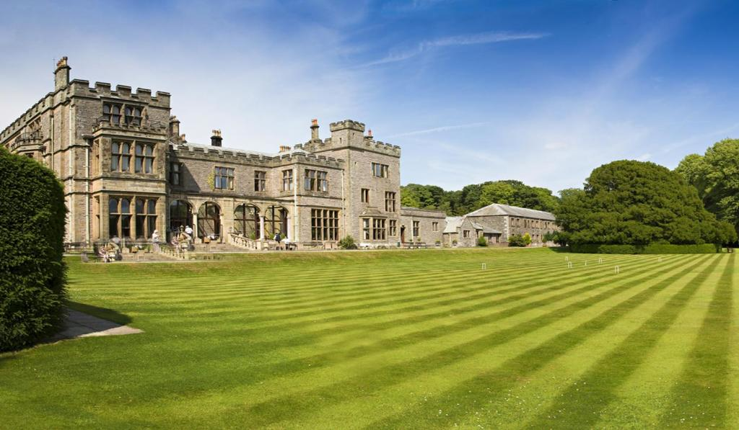
5, Marlborough Avenue  High Harrington  Workington  Cumbria CA14 4NW | 07970 180751 (M)  darryl.davies1@btopenworld.com

